Brian Engel

Module 4 Milestone

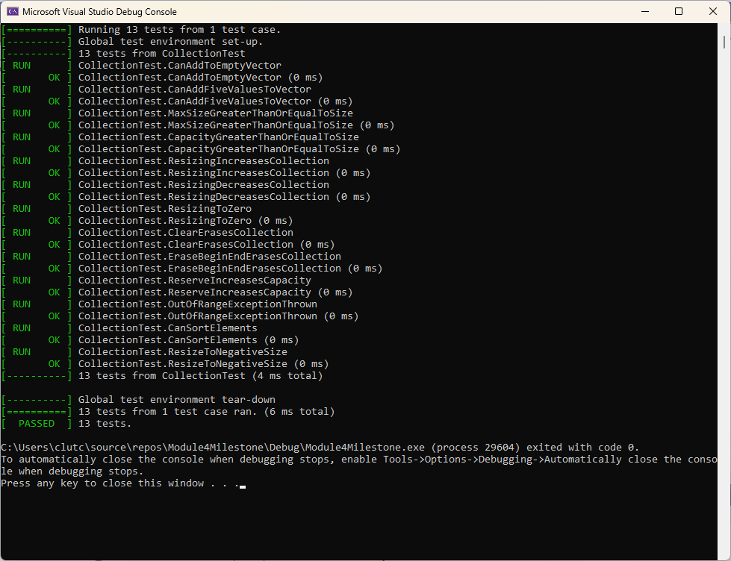

I tried to follow the advice in the guide and used EXPECT when it was important to ensure something but wasn’t the purpose of the actual test and ASSERT when the function of the test was involved. I followed the patterns from the first tests and made sure the collection was empty / size 0 first. I also commented out the first tests that we didn’t have to modify or write so the actual test suite showed the 13 tests that we wrote. Everything went smoothly, although it was a little strange writing the negative tests and having to make something fail in order for it to pass.